Mongo DB ATLAS

What is MongoDB ATLAS?

MongoDB ATLAS is MongoDB but with Cloud capabilities. In simple words, MongoDB ATLAS essentially stores your data in Cloud, and it supports the 3 major players AWS, Azure and Google Cloud. Once you register with ATLAS you will be able to create and manage your Mongo Collections at a single place. It also has something called as “MongoDB Query API” which eliminates the need for having a separate third-party app to access the documents and manage them.

In this learning, we will get a closer look on how to create a MongoDB using ATLAS, how to manage them and how to integrate them with the .NET Core Web API Application.

Pre-requisite:

1. Sign-up for MongoDB ATLAS (It’s free).
2. Visual Studio 2022.

MongoDB Cluster Creation with ATLAS:

Once you have signed up with ATLAS, the next step would be to create a MongoDB Cluster and deploy the same to cloud service provider.

1. Open ATLAS and in the left panel, select Database and click on Build Database.
2. In the next screen, you will be prompted to select the following. Once everything is selected, click on Create.
   1. Type of Cluster – M10 (Pay-as-you-go -> Hourly charge), Serverless (Pay per operation -> Depending on the reads you will be charged), M0 (Free). Select Free for learning purposes.
   2. Cloud Provider – AWS, Azure and Google Cloud. Select AWS since its relevant to our project.
   3. Region – Select the region that is closest to us for faster access. Select Mumbai.
   4. Cluster Name – Type in the name that you desire.
3. Cluster creation takes few minutes. Meanwhile, we need to create authentication for the cluster. Do the following.
   1. Select Username and Password and click on Create User. (Since it’s for learning purpose, we have chosen this)
   2. Add your current IP address to the access list so that you will be able to access the MongoDB.
   3. Click on Finish and Close.
4. Once your DB Cluster is provisioned, you will be able to connect and proceed with working on the data.

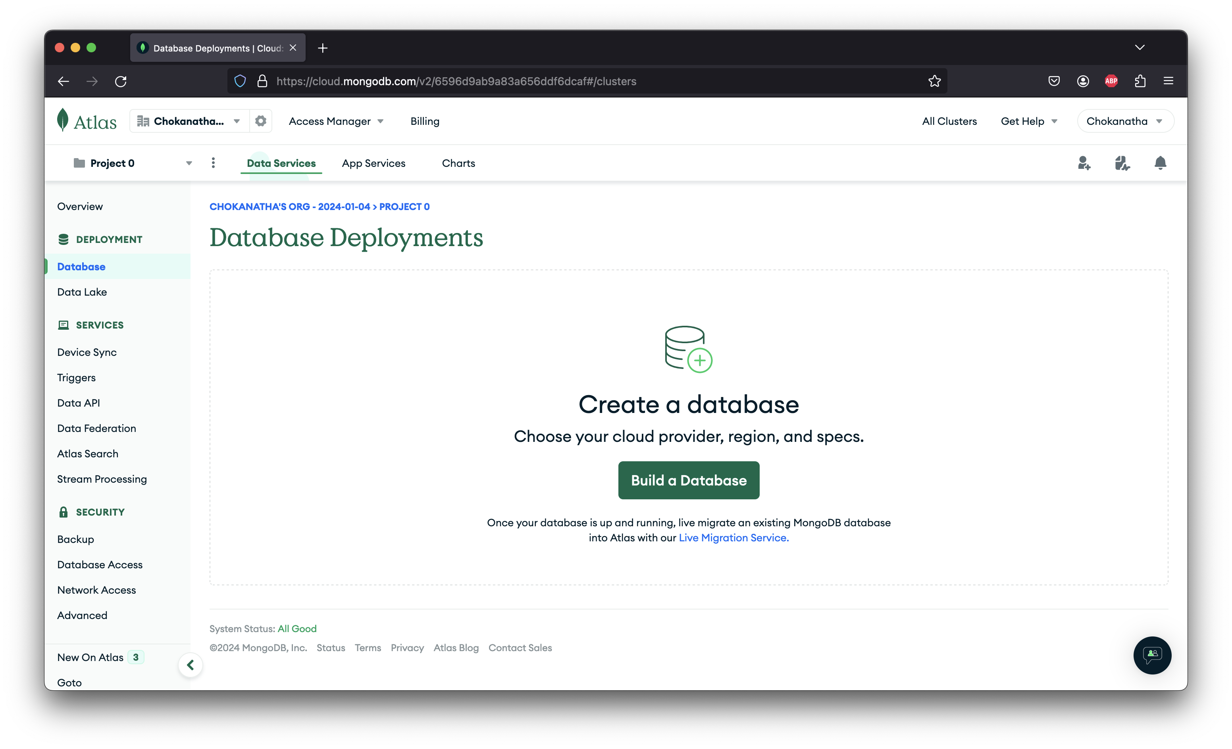

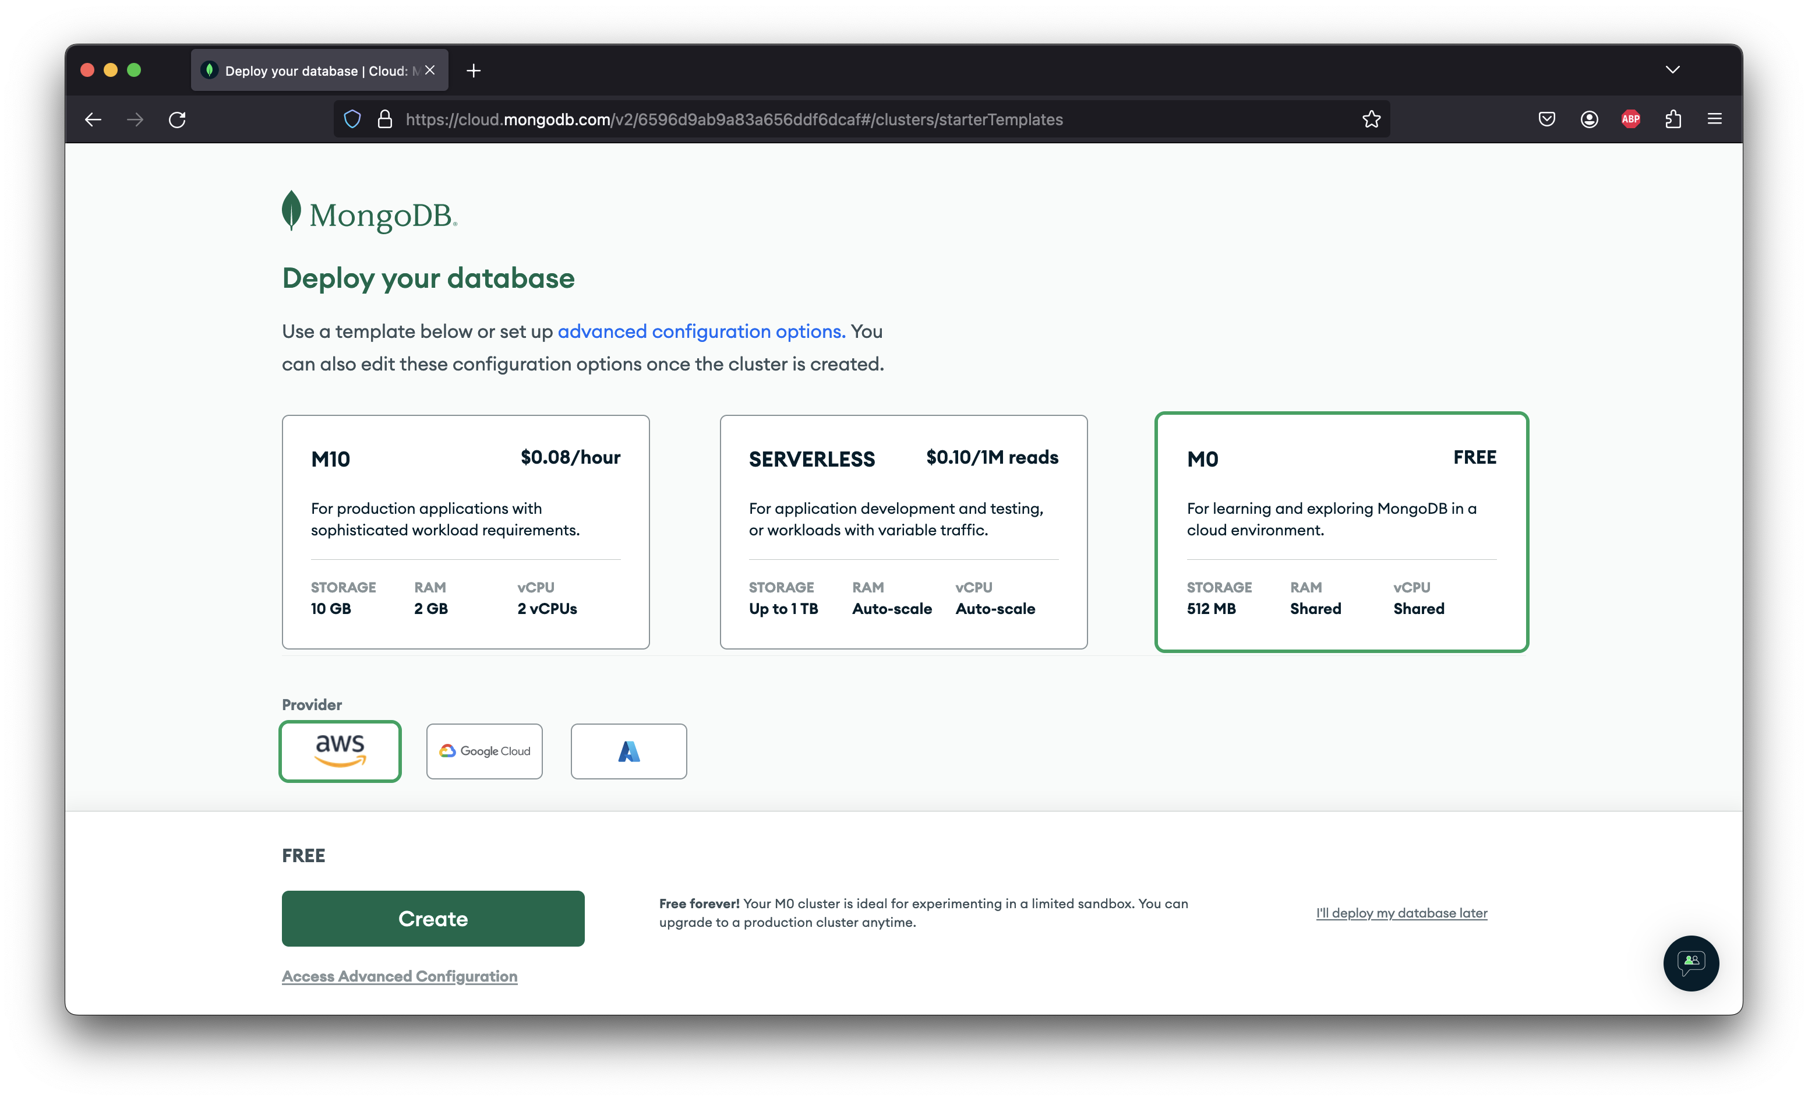

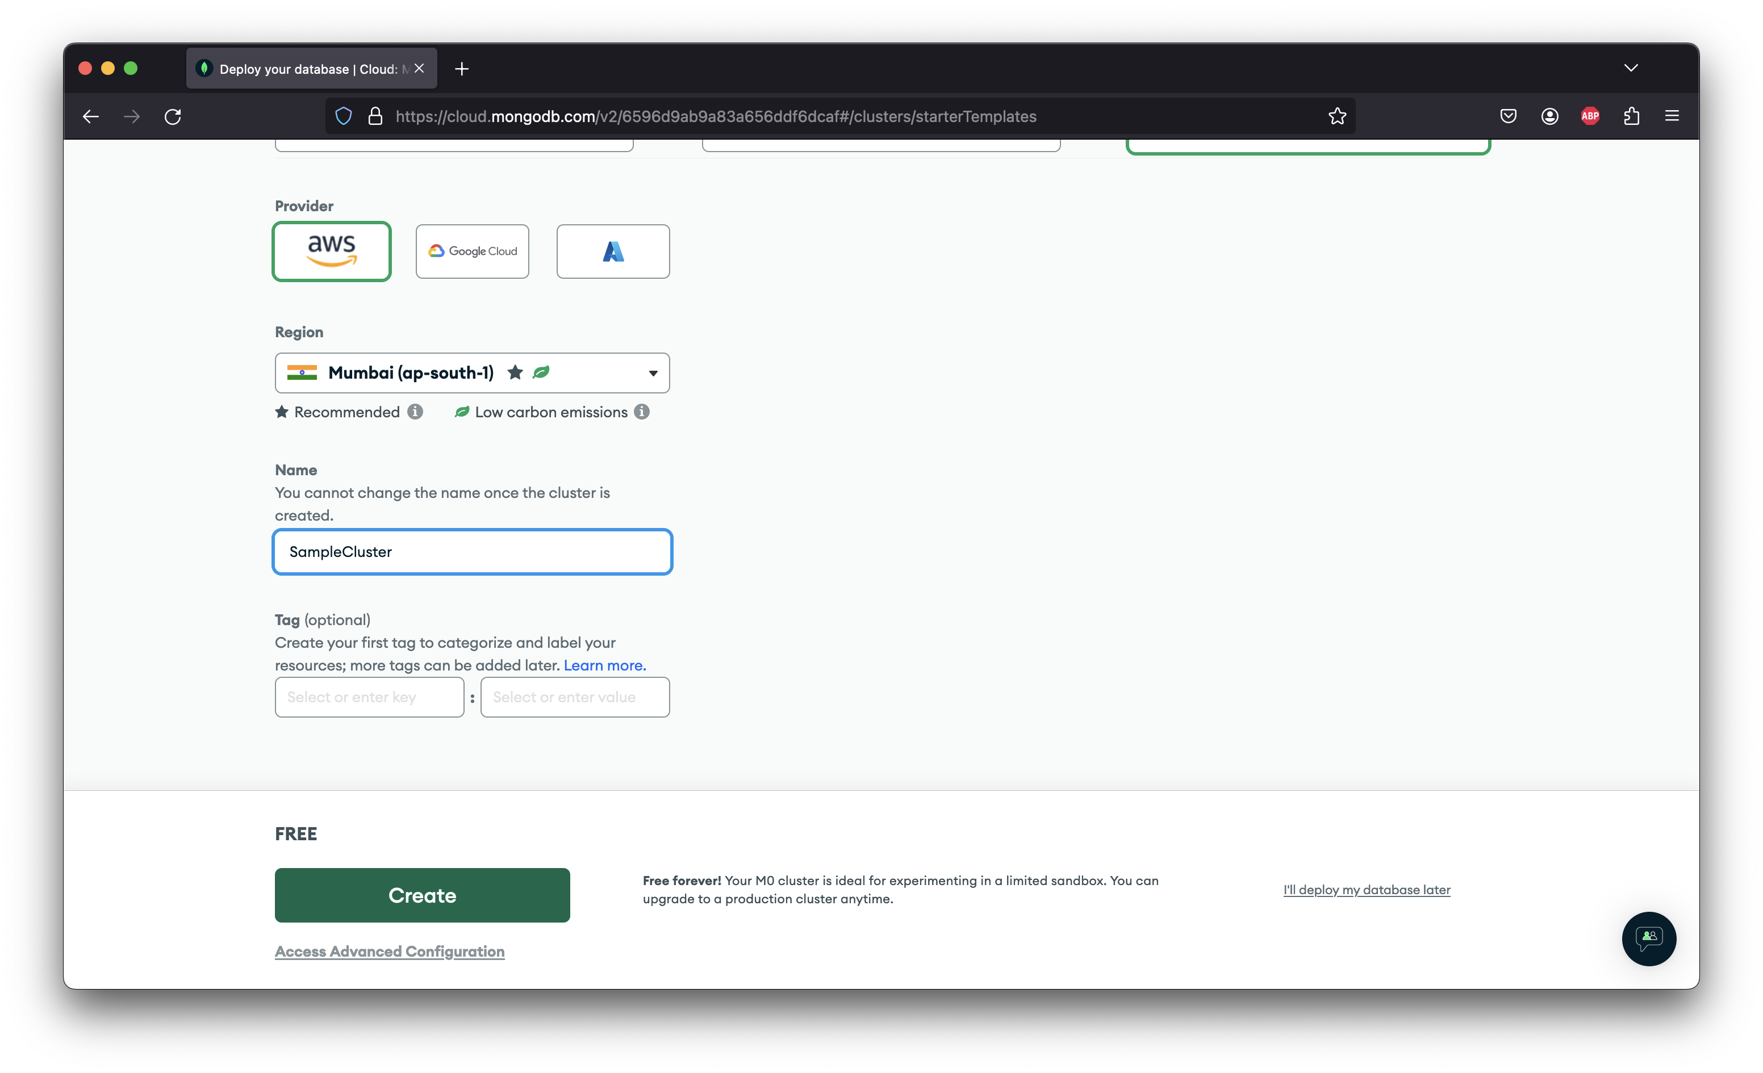

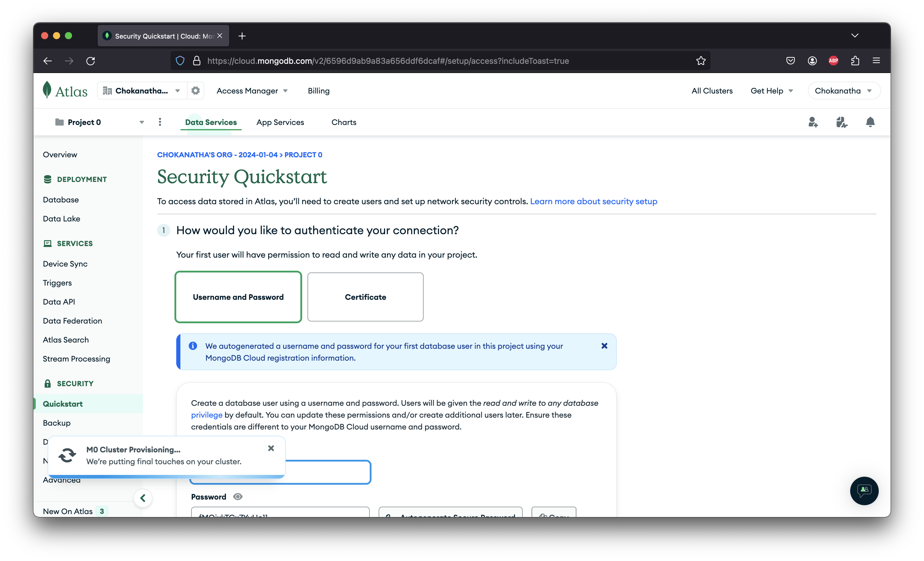

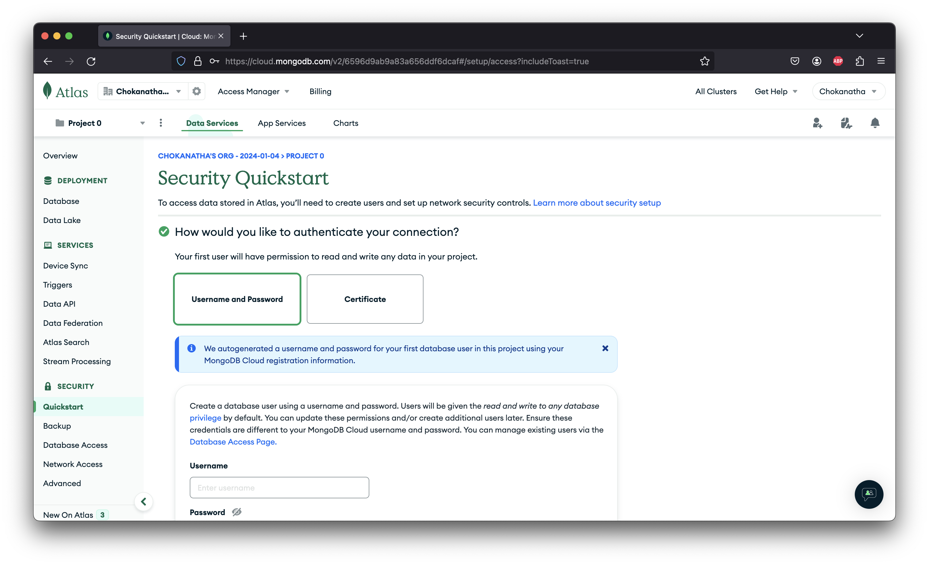

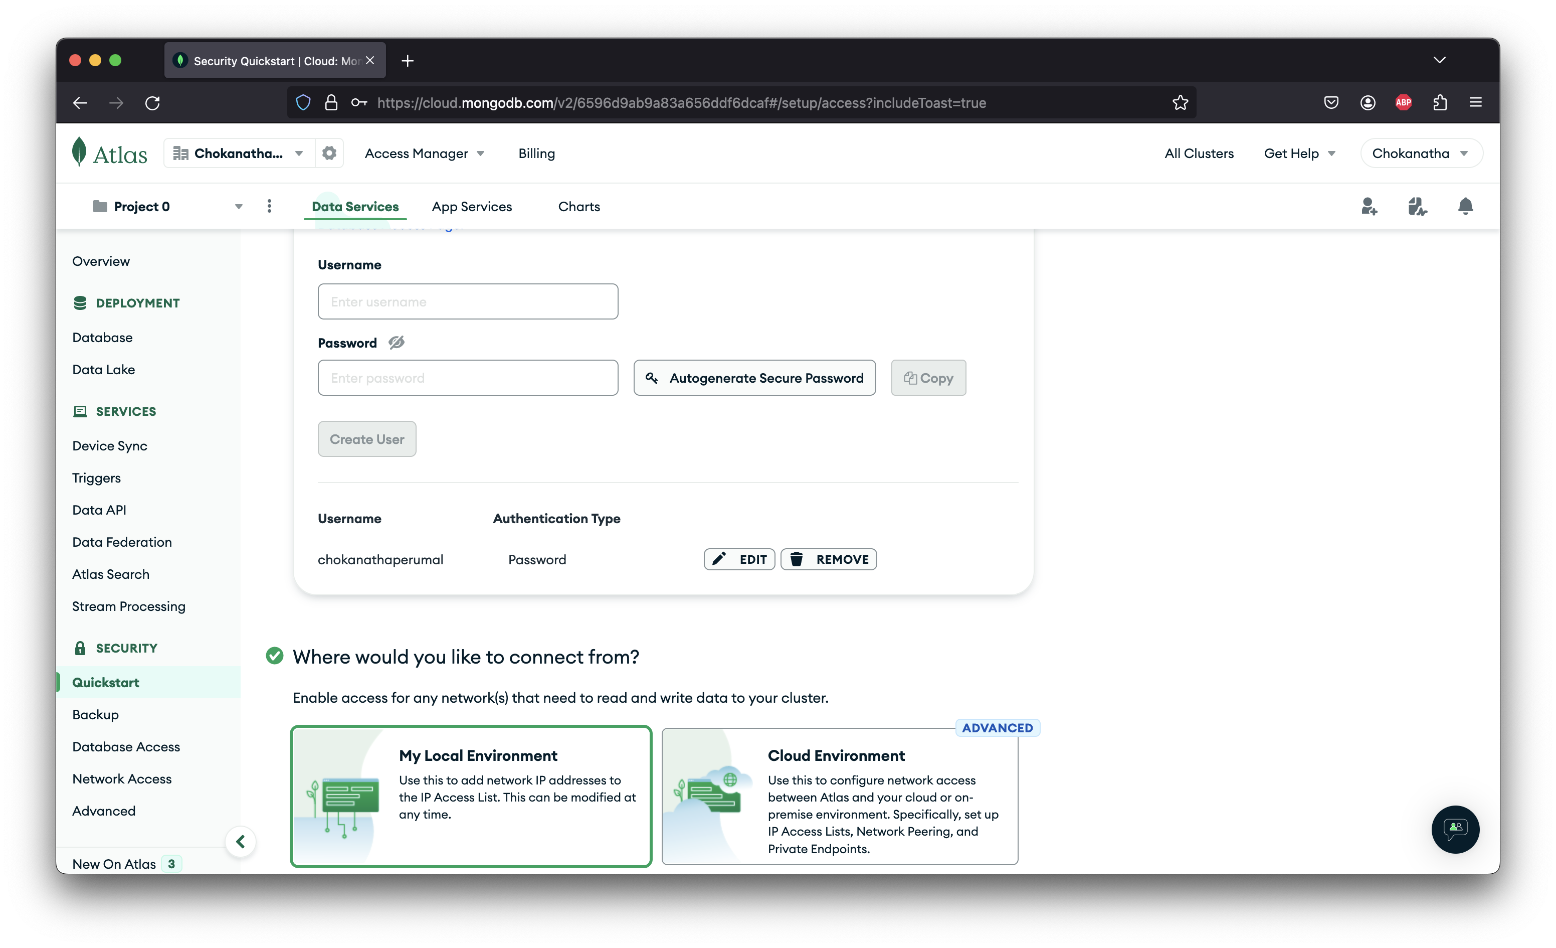

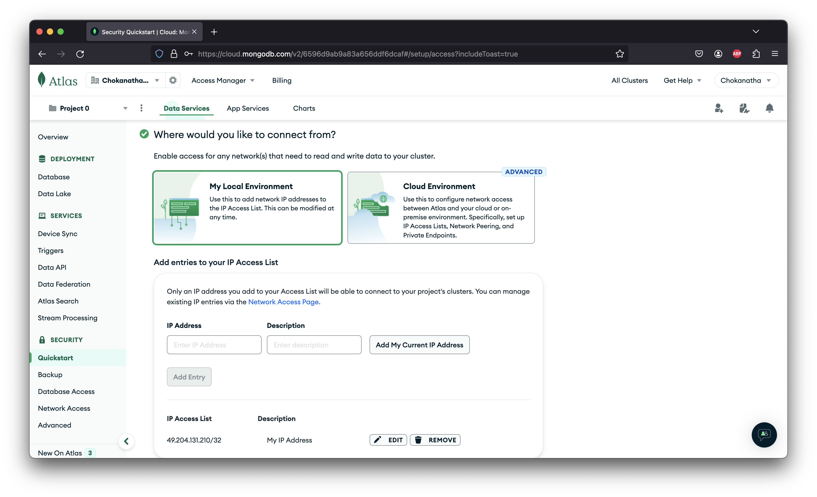

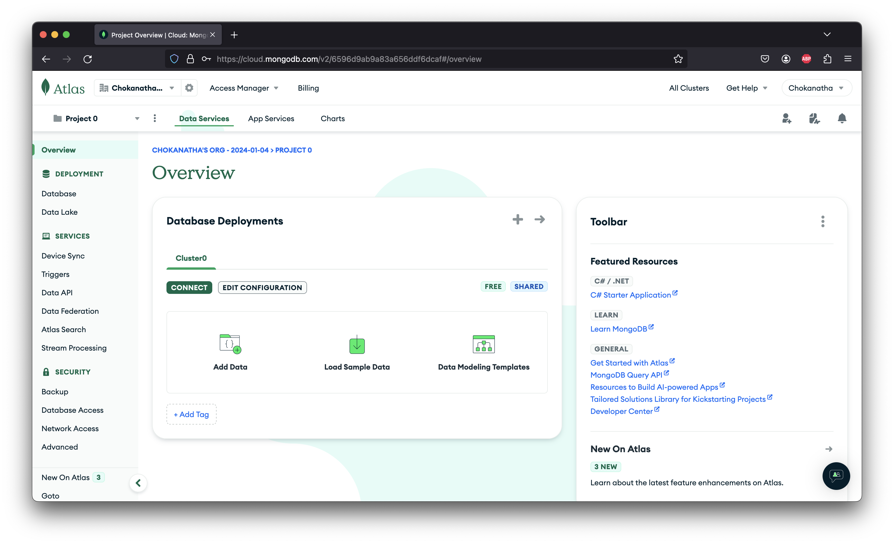

We can ideally click on Add Data to add a new Database, Collections and new Documents in it. By default, MongoDB provides us with “Load Sample Data” option using which we can insert sample databases and collections and work through them as well. Since ATLAS incorporates “Query API” once we open the collection, we will be able to query through them using ATLAS UI. Alternatively, we can also use other apps like Mongo Compass to query as well.

ATLAS with .NET Core API:

Create a new .NET Core Web API project and add the MongoDB.Driver nuget package. Now, for .NET to connect to MongoDB we should be providing the following either directly or we can configure this in appsettings.json file and map them through a class and inject it wherever its required.

1. Connection URL – Click on Database in the left pane and select “Connect” next to the Cluster Name. Choose Drivers and select the .NET driver. We will be able to see the connection string in this window. Copy that, replace the password tag with your password and use it in the VS to connect.
2. Database Name
3. Collection Name

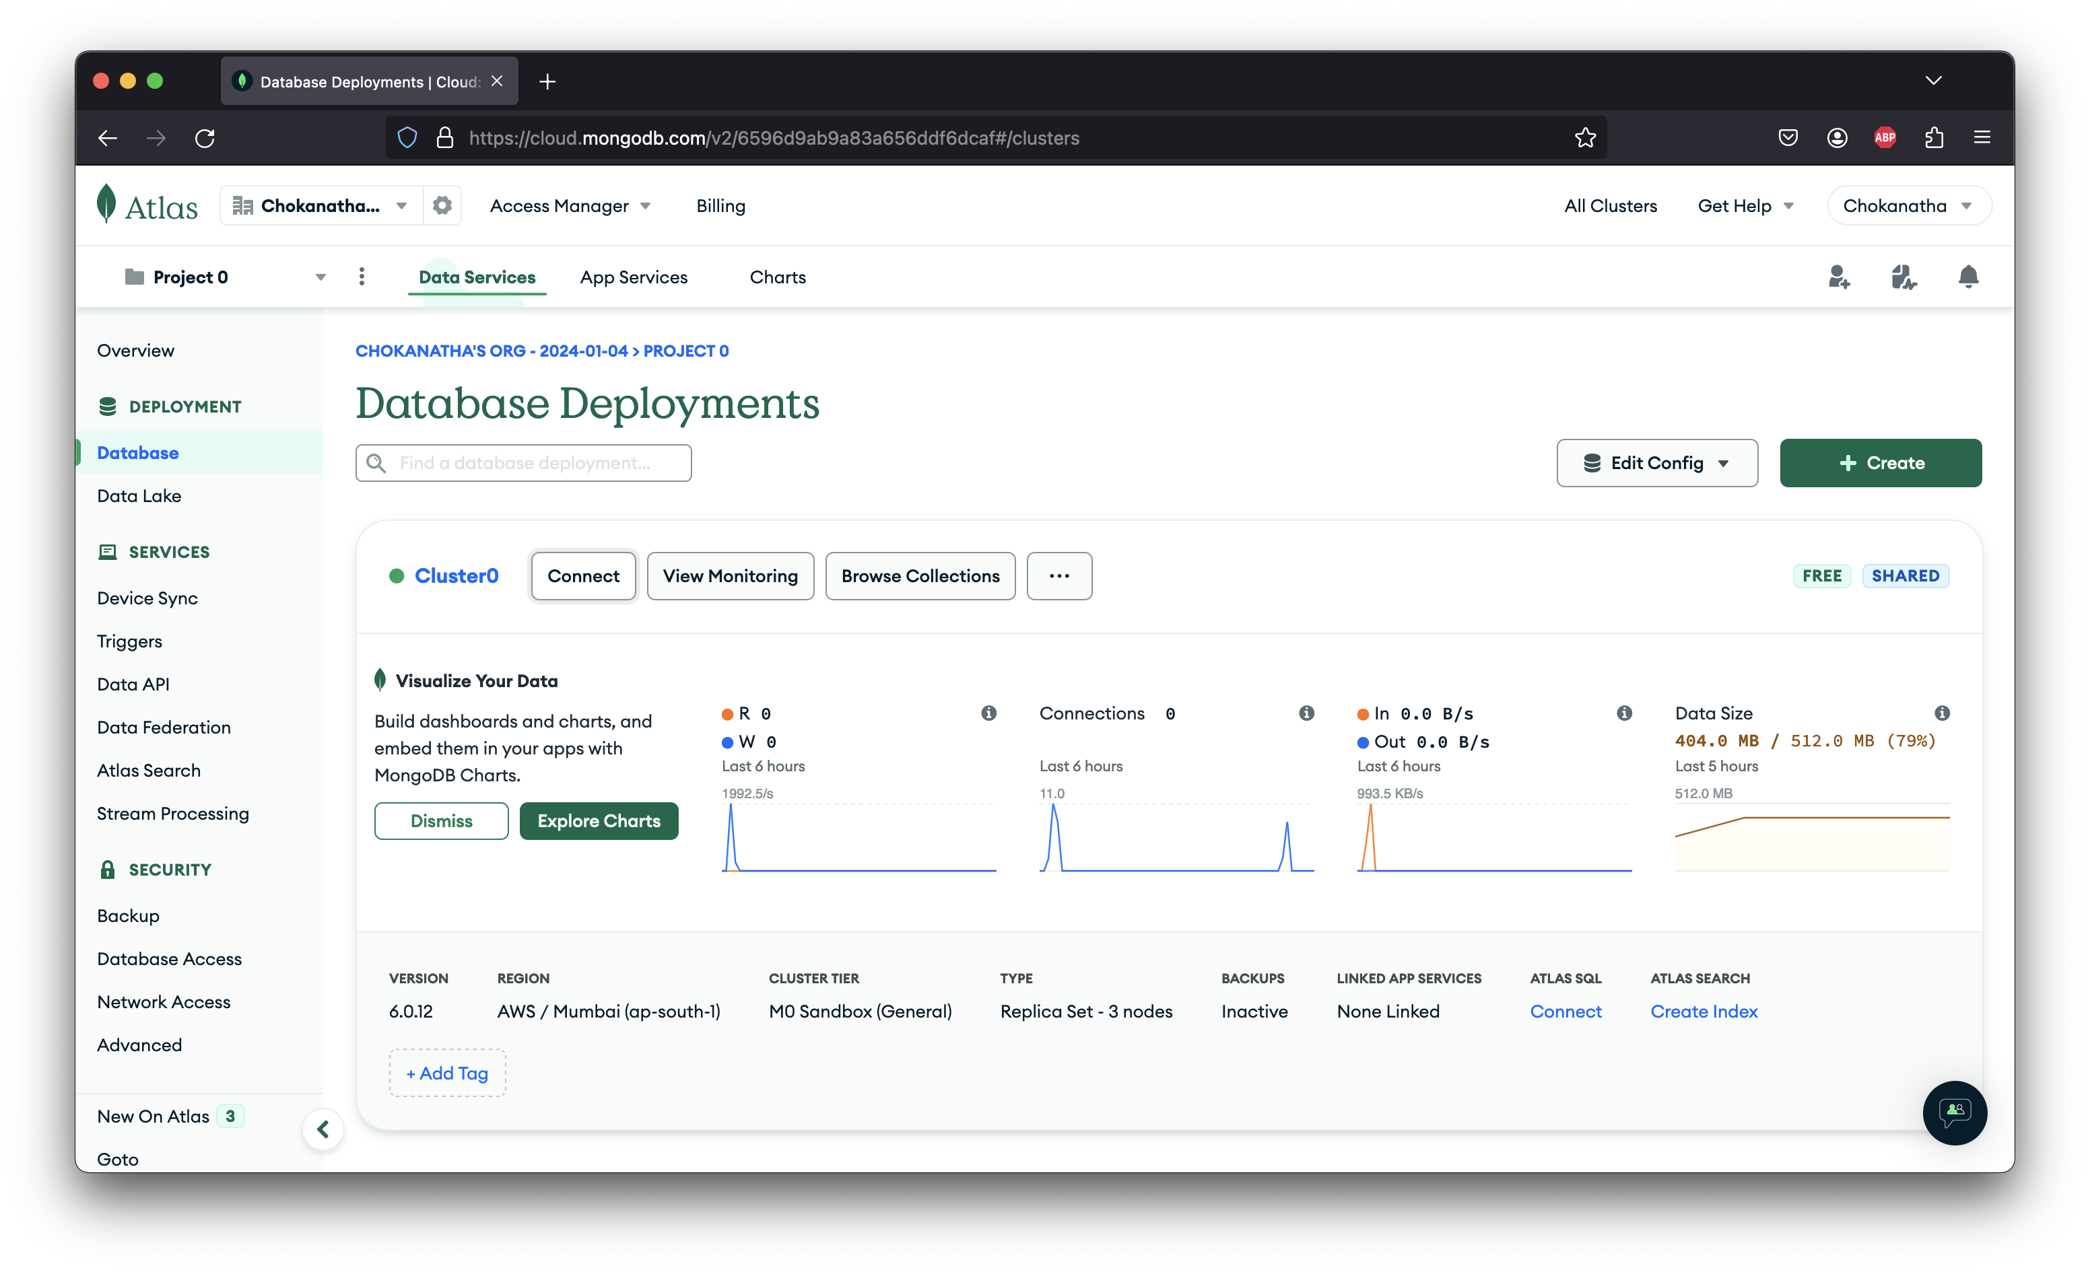

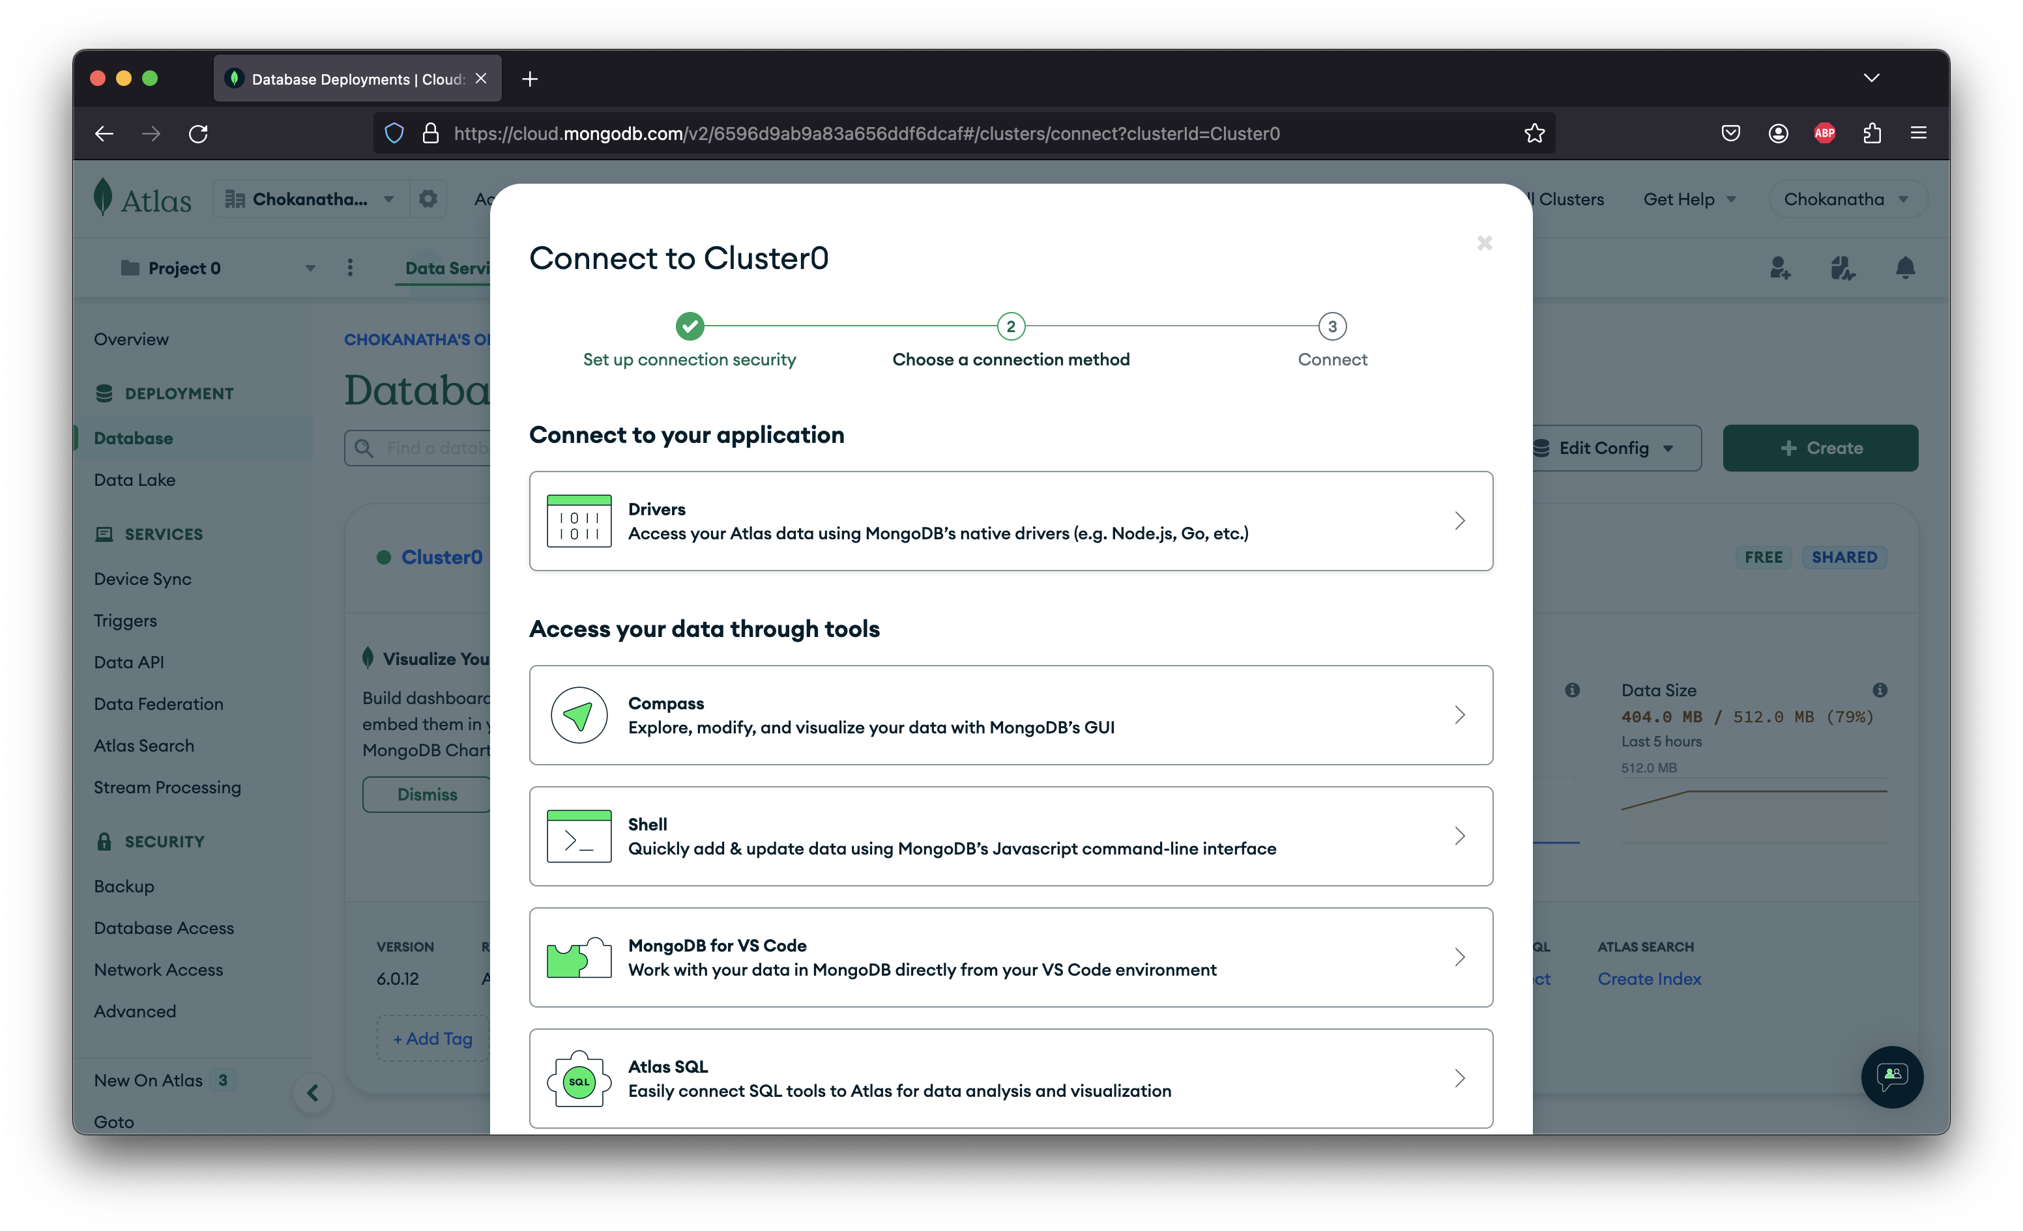

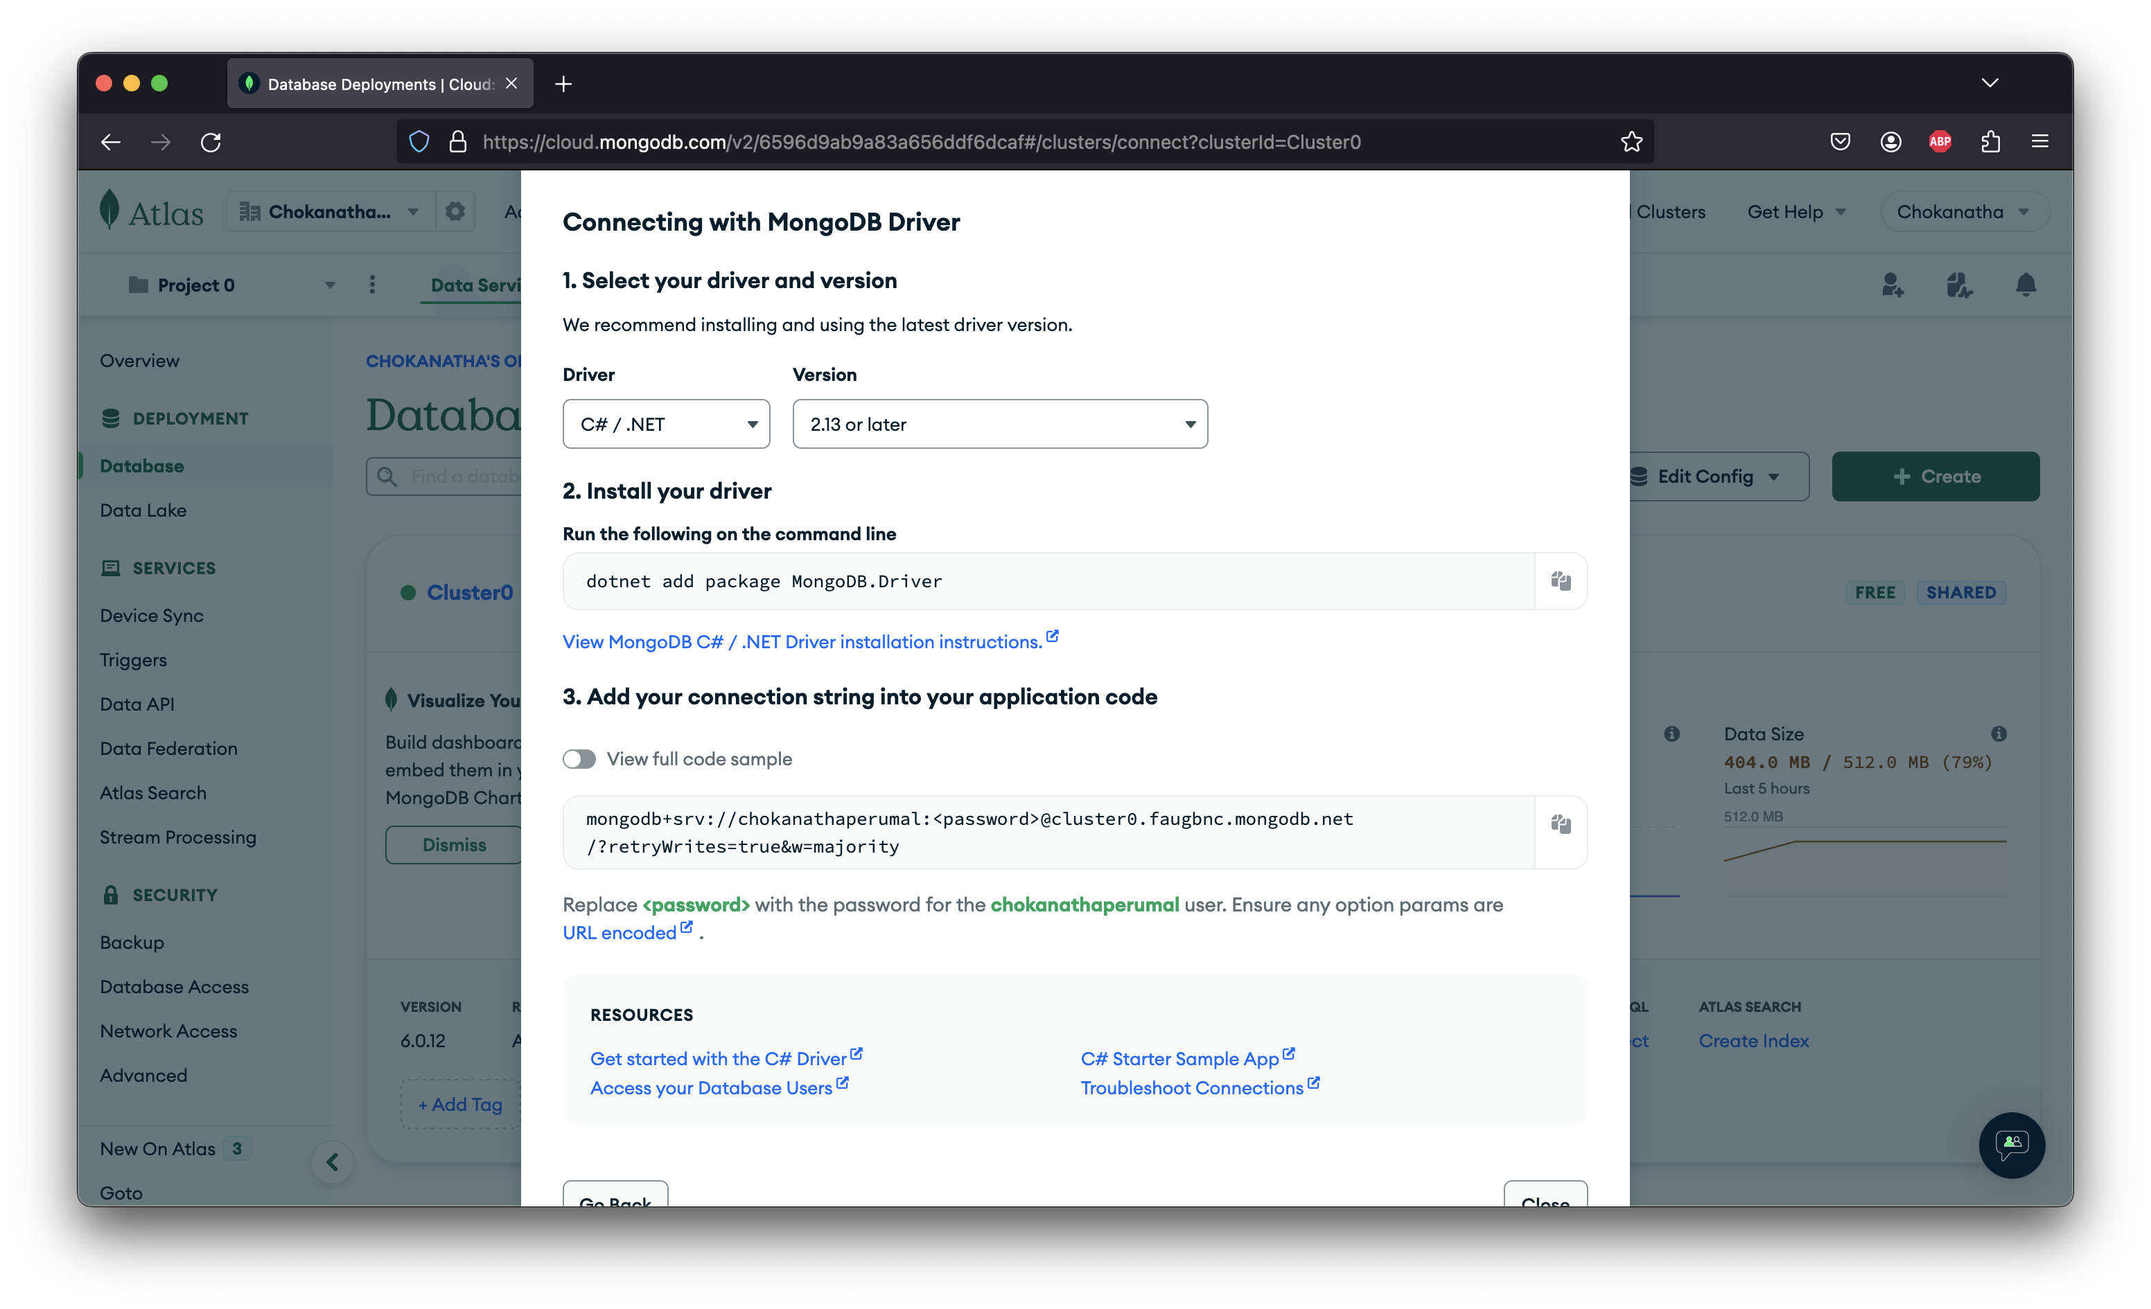

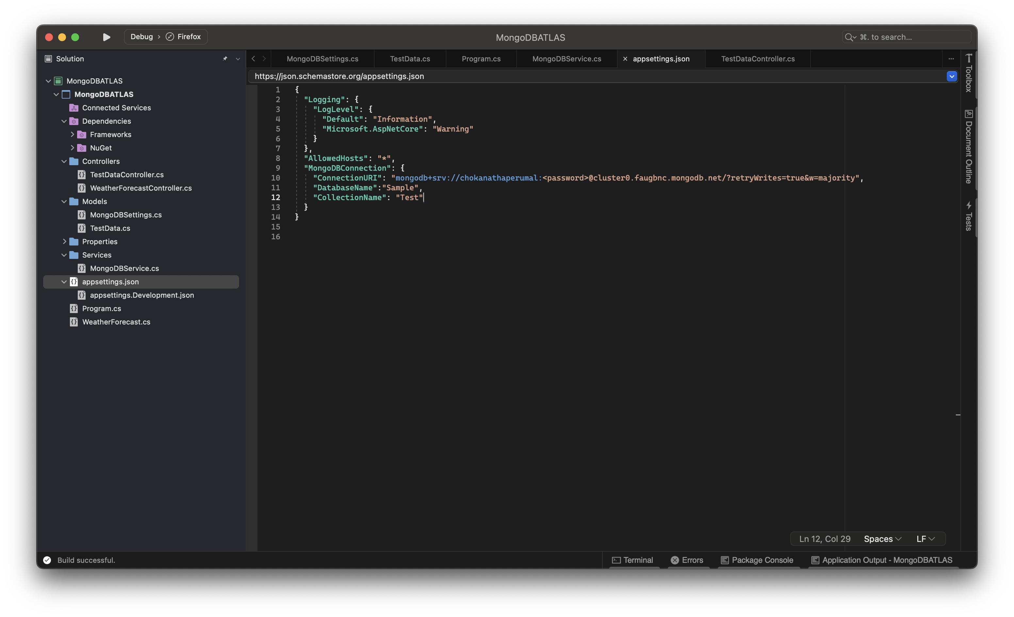

I have created a database named “Sample” and created a new collection called “Test” and using basic .NET Core Web API, I was able to post data into the collection and retrieve the same as well.



